11.

|  |  |  |  |  |  |  |  |
| --- | --- | --- | --- | --- | --- | --- | --- |
| p | q |  | ~ | q | ^ | ~ | p |
| 0 | 0 |  | 1 | 0 | 1 | 1 | 0 |
| 0 | 1 |  | 0 | 1 | 0 | 1 | 0 |
| 1 | 0 |  | 1 | 0 | 0 | 0 | 1 |
| 1 | 1 |  | 0 | 1 | 0 | 0 | 1 |

Output is 1000

|  |  |  |  |  |  |  |  |  |  |
| --- | --- | --- | --- | --- | --- | --- | --- | --- | --- |
| p | q |  | ~ | (p | v | (q | ^ | ~ | p) |
| 0 | 0 |  | 1 | 0 | 0 | 0 | 0 | 1 | 0 |
| 0 | 1 |  | 0 | 0 | 1 | 1 | 1 | 1 | 0 |
| 1 | 0 |  | 0 | 1 | 1 | 0 | 0 | 0 | 1 |
| 1 | 1 |  | 0 | 1 | 1 | 1 | 0 | 0 | 1 |

Output is 1000

They are identical

12.

|  |  |  |  |  |  |  |  |  |  |  |  |  |  |  |  |
| --- | --- | --- | --- | --- | --- | --- | --- | --- | --- | --- | --- | --- | --- | --- | --- |
| p | q | r |  | ((q | v | p) | ^ | (~ | q | v | r)) | -> | (r | v | p) |
| 0 | 0 | 0 |  | 0 | 0 | 0 | 0 | 1 | 0 | 1 | 0 | 1 | 0 | 0 | 0 |
| 0 | 0 | 1 |  | 0 | 0 | 0 | 0 | 1 | 0 | 1 | 1 | 1 | 1 | 1 | 0 |
| 0 | 1 | 0 |  | 1 | 1 | 0 | 0 | 0 | 1 | 0 | 0 | 1 | 0 | 0 | 0 |
| 0 | 1 | 1 |  | 1 | 1 | 0 | 1 | 0 | 1 | 1 | 1 | 1 | 1 | 1 | 0 |
| 1 | 0 | 0 |  | 0 | 1 | 1 | 1 | 1 | 0 | 1 | 0 | 1 | 0 | 1 | 1 |
| 1 | 0 | 1 |  | 0 | 1 | 1 | 1 | 1 | 0 | 1 | 1 | 1 | 1 | 1 | 1 |
| 1 | 1 | 0 |  | 1 | 1 | 1 | 0 | 0 | 1 | 0 | 0 | 1 | 0 | 1 | 1 |
| 1 | 1 | 1 |  | 1 | 1 | 1 | 1 | 0 | 1 | 1 | 1 | 1 | 1 | 1 | 1 |

Output is 11111111

13.

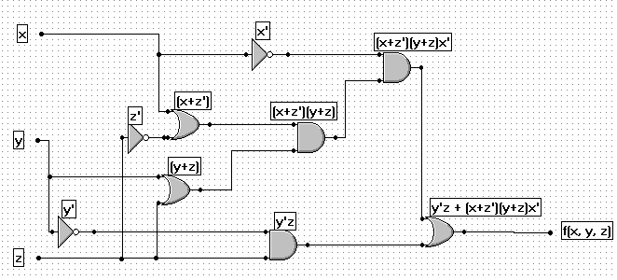

16.

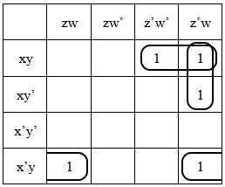

x’yw + xyz’ + xz’w ……… raw

y(x’w + xz’) + xz’w ……... slightly reduced